BOX
OFFICE
ONLY
THE MENUHIN HALL - AUTUMN WINTER 2018/19 |  |  |  |  |  |  |  |  | Box Office |  |  | /15
FRIENDS FORM MUST BE RETURNED NO LATER THAN FRIDAY 10TH AUGUST 2018
Full Name |  |  |  |  |  |  | Contact Number
Address
Email Address
 | Please tick box to be issued with a  Menuhin Hall Parking Permit which allows a wheelchair customer to park at the rear of the Hall. This issued permit will ensure that a fixed seat is removed in the auditorium to allow wheelchair access. |  |  |  |  | Please tick box to APPLY for level access parking if you use a walking frame or sticks and cannot attend without a permit. Wheelchair customers will be given priority. Availability for these spaces is very limited. See Booking Form for more information.
CONCERT |  |  | DAY | DATE | TIME |  | FRIENDS |  |  |  | GUESTS |  |  | TOTAL
EACH FRIEND IS ENTITLED TO BOOK 2 TICKETS PER CONCERT |  |  |  |  |  |  | QTY | PRICE |  |  | QTY |  | PRICE | £
JOSÉ RAMÓN MÉNDEZ |  |  | Thursday | 20 SEP 2018 | 7.30pm |  |  | £25 |  |  |  |  | £25
SEPTEMBER SHOWCASE |  |  | Thursday | 27 SEP 2018 | 7.30pm |  |  | £17.50 |  |  |  |  | £17.50
THE ENDELLION  STRING QUARTET |  |  | Thursday | 04 OCT 2018 | 7.30pm |  |  | £25 |  |  |  |  | £25
NATALIA GUTMAN MASTERCLASS |  |  | Friday | 12 OCT 2018 | 2.30pm |  |  | £5 |  |  |  |  | £8
OCTOBER SHOWCASE |  |  | Tuesday | 16 OCT 2018 | 7.30pm |  |  | £17.50 |  |  |  |  | £17.50
EARLY NOVEMBER SHOWCASE |  |  | Thursday | 08 NOV 2018 | 7.30pm |  |  | £17.50 |  |  |  |  | £17.50
ARTUR PIZARRO |  |  | Friday | 23 NOV 2018 | 7.30pm |  |  | £25 |  |  |  |  | £25
LATE NOVEMBER SHOWCASE |  |  | Friday | 30 NOV 2018 | 7.30pm |  |  | £17.50 |  |  |  |  | £17.50
AFTERNOON CHRISTMAS SHOWCASE |  |  | Monday | 10 DEC 2018 | 3pm |  |  | £20 |  |  |  |  | £20
EVENING CHRISTMAS SHOWCASE |  |  | Tuesday | 11 DEC 2018 | 7.30pm |  |  | £20 |  |  |  |  | £20
ALINA IBRAGIMOVA |  |  | Tuesday | 15 JAN 2019 | 7.30pm |  |  | £25 |  |  |  |  | £25
JANUARY LUNCHTIME SHOWCASE |  |  | Friday | 25 JAN 2019 | 1.15pm |  |  | £10 |  |  |  |  | £10
MID FEBRUARY SHOWCASE |  |  | Thursday | 14 FEB 2019 | 7.30pm |  |  | £17.50 |  |  |  |  | £17.50
PICCADILLY DANCE ORCHESTRA |  |  | Saturday | 23 FEB 2019 | 7.30pm |  |  | £25 |  |  |  |  | £25
LATE FEBRUARY SHOWCASE |  |  | Thursday | 28 FEB 2019 | 7.30pm |  |  | £17.50 |  |  |  |  | £17.50
PLEASE NOTE: CONCERTS NOT ON THIS FORM CAN BE BOOKED FROM  TUESDAY 28TH AUGUST WHEN GENERAL BOOKING OPENS  Online booking is now open for some events  SORRY WE CANNOT ACCEPT STAMPED ADDRESSED ENVELOPES  ALL TICKETS ARE NON-REFUNDABLE |  |  |  |  |  |  |  |  |  |  | TICKET TOTAL £
 |  |  |  |  |  |  |  |  |  |  | PLUS POSTAGE |  |  | £1.00
 |  |  |  |  |  |  |  |  |  |  | TOTAL INC POSTAGE £

THE MENUHIN HALL - AUTUMN WINTER 2018 / 19
Why can’t I book for these events on my booking form?
Priority booking does not include events put on by outside hirers.
OUTSIDE HIRE EVENTS |  |  |  |  |  |  | DATE |  |  |  |  |  |  | ON SALE
The Genius of Gilbert & Sullivan with Peter Medhurst |  |  |  |  |  |  | Monday 8 October 2018 10.30am |  |  |  |  |  |  | Online: Now  Phone: 28 August 10am
The Cobham Band |  |  |  |  |  |  | Saturday 27 October 2018 7.30pm |  |  |  |  |  |  | Online: 1 Aug 2018  Phone: 28 August 10am
The Grange 80th Anniversary Concert |  |  |  |  |  |  | Saturday 1 December 2018 7.30pm |  |  |  |  |  |  | Online: Now  Phone: 28 August 10am
Twelfth Night With Peter Medhurst |  |  |  |  |  |  | Sunday 6 January 2019 3pm |  |  |  |  |  |  | Online: Now  Phone: 28 August 10am
YOUR PAYMENT DETAILS
NO CHEQUES PLEASE - ONLY BANK CARD DETAILS TO ACCOMPANY THIS FORM
NAME ON CARD
TICK CARD TYPE | CREDIT |  |  | DEBIT |  |  |  | MASTERCARD |  |  |  |  | VISA
CARD NUMBER
EXPIRY DATE |  |  | / |  |  | SECURITY NUMBER
NAME OF HOUSE OR HOUSE NUMBER |  |  |  |  |  |  |  |  |  |  | POST CODE
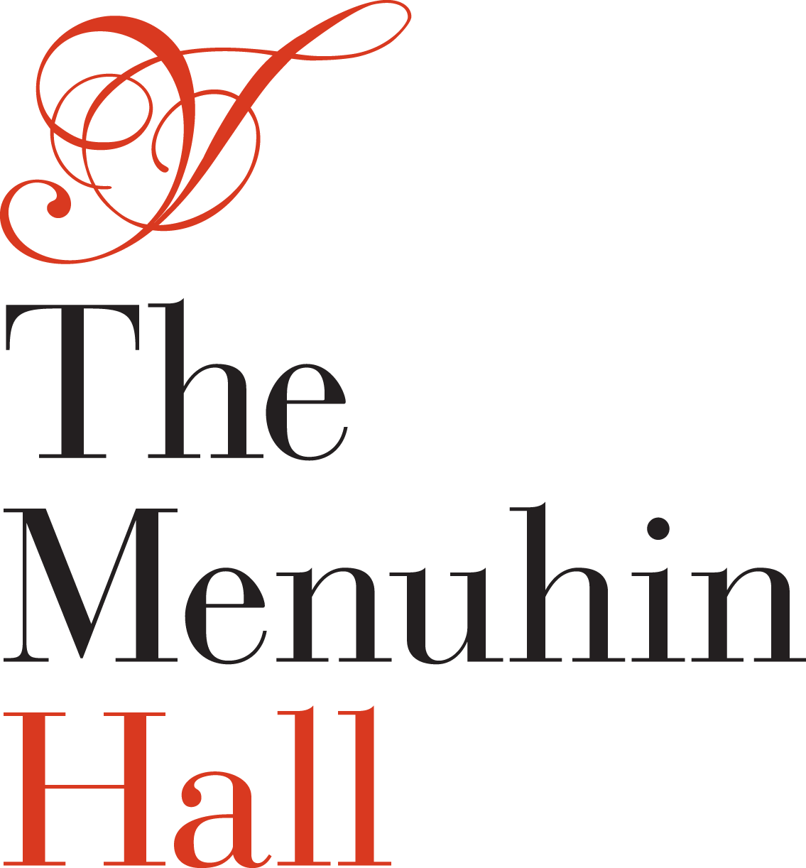
BOX OFFICE USE



Friends Booking
Form Autumn Winter
2018/19

Dear Friend(s),

We are delighted to introduce to The Menuhin Hall for the first time, two excellent pianists José Ramón Méndez and Artur Pizarro, definitely two concerts not to be missed. If you fancy an evening of swing and jazz, then the Piccadilly Dance Orchestra will be entertaining us with toe-tapping tunes from the 1920s and 30s. We have added a further Showcase Concert for our talented pupils to amaze you with the performances, so we look forward to seeing you at many of our events over the next months.

 POSTAL BOOKING  Friends Priority Booking forms must be submitted by Friday 10th August, forms received after this date will not be processed during the Priority period.

The Menuhin Hall Box Office will be closed to visitors from Monday 13th August until Friday 26th August inclusive. Please note that telephone bookings cannot be taken during this time.

METHOD OF PAYMENT for Friends on paper booking forms. Friends should enter their Bank Card details on the attached form. Payment will only be taken for the tickets allocated. The Menuhin Hall is legally compliant for transactions processed in this way.

If you have concerns about your card details going through the post, then either leave the form with the Box Office, or if it is closed, use the post box outside The Menuhin Hall by Friday 10th August, or send your form by recorded delivery.

No customer financial details are held on record. ALL DATA IS DESTROYED. Friends who do not have facilities to pay by credit or debit card should contact the Box Office on 08700 842020.

 ONLINE BOOKING
This is an easy alternative to filling out the Friends Priority Booking Form. It is ideal if you are away at the time the forms are posted out to Friends. Our online booking facility opens on Monday 13th August at 10am. If you cannot remember your password, please create a new password on our website before starting your booking. There is an online Booking Guide available on our web site to assist you if needed. Limited online support will also be available by contacting the Box Office on 08700 842020.

GENERAL BOOKING
PLEASE NOTE - General Booking for all other concerts opens on Tuesday 28th August at 10am

FRIEND(S) INFORMATION
- Friends can book 4 seats for all concerts during the priority booking period only, subject to availability.

IF YOU HAVE A QUERY?
- If you are unsure how to book, please leave a message on the answer phone and we will do our best to get back to you as soon as we can, but please only leave one message.

BOX
OFFICE
ONLY
HOW DO I APPLY FOR A GROUP BOOKING OR APPLY FOR TICKETS FOR FRIENDS WHO DO NOT LIVE AT THE SAME ADDRESS AND WHO WOULD LIKE TO SIT TOGETHER?
- Complete one form, including the name(s) of additional Friend(s).
- One payment only will be taken and it should be in the name of the Friend completing the form.

HOW DO I COMPLETE MY FORM?
- Select your ticket requirements from the season’s listings.
- Please enter your card details for payment in the boxes provided.
- Return the completed form to The Menuhin Hall Box Office, Autumn Winter 2018/19, The Yehudi Menuhin School, Stoke d’Abernon, Surrey, KT11 3QQ no later than Friday 10th August 2018.

HOW DO I PAY?
- Payment will be taken by card FOR THE TICKETS ALLOCATED ONLY.
- A card transaction receipt will be sent out with your allocated tickets.
- Please do NOT send cheques with your ticket request form.

HOW/WHEN DO I RECEIVE MY TICKETS?
Your tickets will be posted out before the General booking opens on Tuesday 28th August, if you have not received your tickets and you applied during the priority booking period please contact the Box Office immediately.
You may have applied for tickets for an event that has sold out. Once you receive your tickets, please check them and contact us as soon as possible if you believe an error has been made.

PARKING FOR WHEELCHAIR PATRONS
- Patrons who use a wheelchair will require level access to the Hall and will automatically be issued with a level access parking permit. This issued permit will ensure that a fixed seat is removed in the auditorium to allow wheelchair access.

MENUHIN HALL LEVEL ACCESS PARKING PERMITS
- Non-wheelchair patrons who use a walking frame or sticks and cannot attend without level access to the Hall may apply for a parking permit.
- They will be informed by the Box Office if their application has been successful at the end of the Priority Booking Period.
- Please note these spaces can only be allocated by The Box Office.

BLUE BADGE HOLDER PARKING

- Blue badge holders may park in the 6 unreserved bays available in the lower car park.
- Blue badges do not automatically entitle the holder to level access parking.
- Please note that access to the Menuhin Hall from the lower car park involves 13 steps and approximately an 80 yard walk.

MENUHIN HALL LEVEL ACCESS WITHOUT A PARKING PERMIT
- Patrons who require level access to the Menuhin Hall and do not have a Level Access Parking Permit can be dropped off behind the Hall in the Parking Permit area between 6.45pm and 7pm. Assistance can be provided, if required, by a member of staff.

GENERAL INFORMATION
- Further booking information can be found on our website www.themenuhinhall.co.uk
- We cannot process email requests or telephone bookings during the Priority Booking Period.
- Please note Friends are not guaranteed tickets, but every effort is made to accommodate requests.
- Please do not ask for specific seats on your forms (unless for medical reasons).
- Only requests on The Menuhin Hall booking forms will be accepted.
- We regret that we are unable to enter into any correspondence during the Priority Booking Period.

IMPORTANT NOTE
If you have submitted a paper allocation form, please do not book tickets online at the same time.
No refunds will be offered on duplicate bookings.

